- Download a public time series dataset of daily temperature for any Indian city (e.g., from Kaggle or data.gov.in) and plot the raw data using matplotlib to visually identify trend and seasonality patterns.
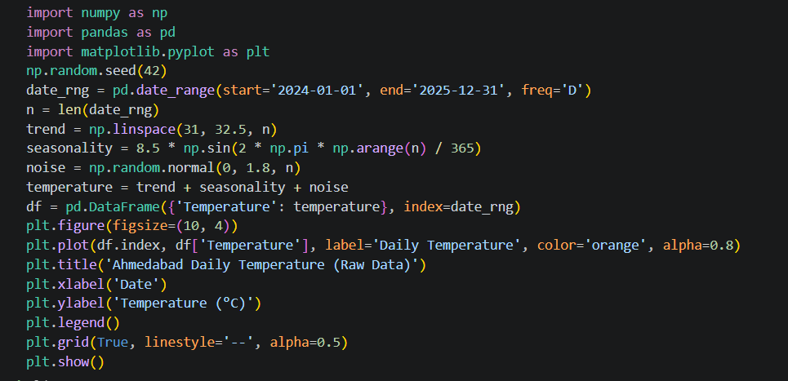

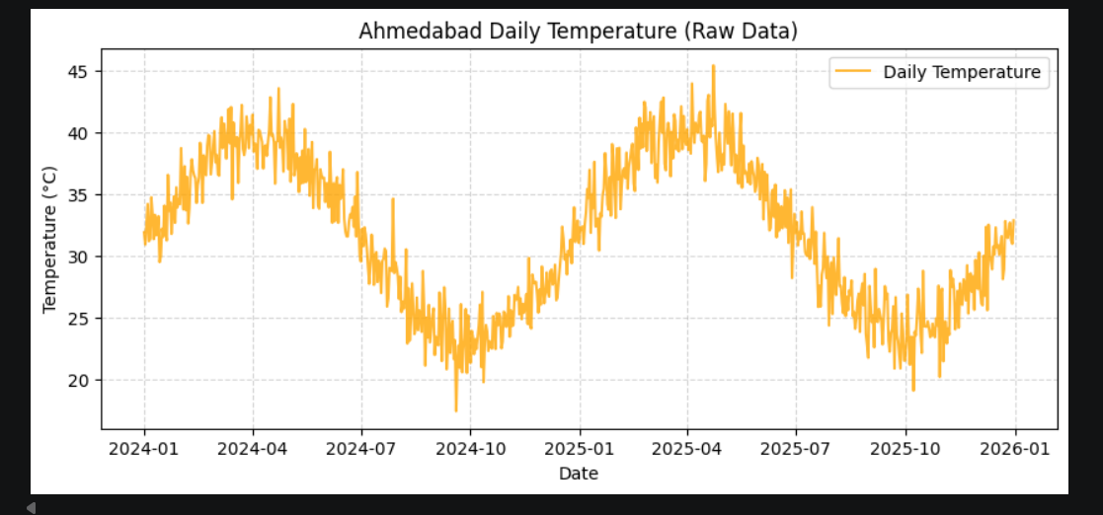

- Write Python code to decompose the temperature time series into trend, seasonal, and residual components using the statsmodels seasonal_decompose() function, and plot each component separately.

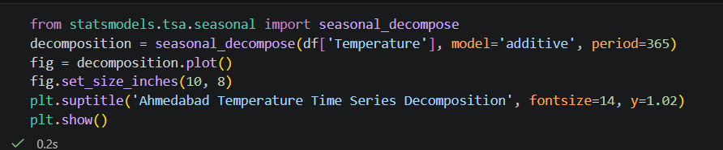

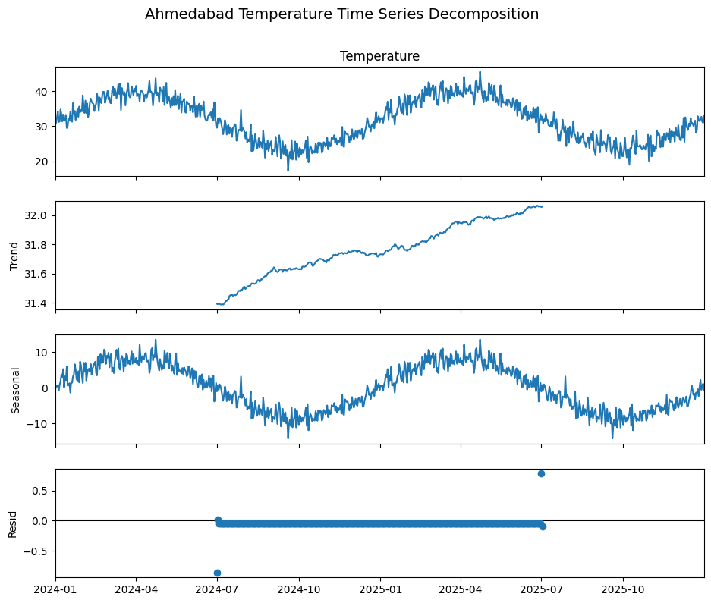

- Check if your temperature time series is stationary using the Augmented Dickey-Fuller (ADF) test from statsmodels.tsa.stattools.adfuller, and print the test statistic and p-value. If the p-value is less than 0.05, the series is likely stationary.
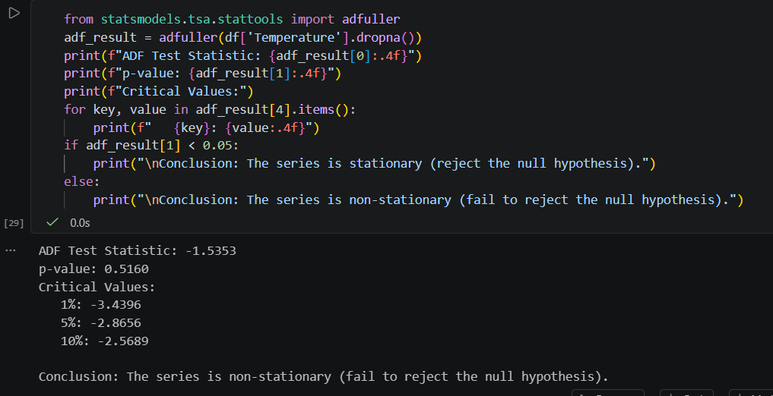

- Apply a moving average smoothing technique (window size 7) to your time series and plot both the original and smoothed series on the same graph to compare.
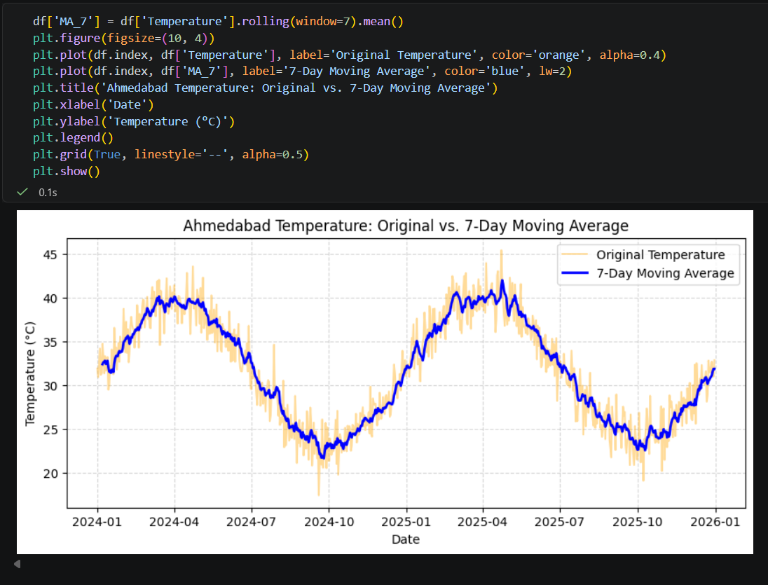

- Fit an ARIMA model to your temperature data using statsmodels.tsa.arima.model.ARIMA, and forecast the next 7 days. Display the predicted values and plot them along with the original series. Use (p,d,q) parameters that you determine based on your ADF test and visual analysis.

